Lincoln High School

Program for Scientific Inquiry (PSI)

Parent/Student Information Packet

# Program for Scientific Inquiry (PSI)

The United States government concern about maintaining enough people in the science and engineering workforce for the past several years is urgent. Other countries have surpassed our nation in the development of STEM (science, technology, engineering, and math) expertise. Currently, the U.S. ranks 29 out of 109 countries in the percentage of 24-year-olds who have earned a mathematics or science degree. People who pursue STEM careers are essential to United States technological leadership, innovation, manufacturing, and services. These people are vital to the country’s economic strength, national defense, and other societal needs. In 2012, according to the Occupational Employment Statistics survey data, only 6.2 million people were employed as scientists and engineers in the U.S., accounting for 4.7% of the total national employment. The scientist and engineering workforce are expected to be the fastest-growing sector of the U.S. economy in the years to come.

Congress has enacted many programs to support the education and development of scientists and engineers. In 2011, a total of 3.4 billion dollars was spent by U.S. Federal agencies on STEM (science, technology, engineering, and math) education, of which 1.1 billion dollars was invested in K-12. Emphasizing STEM education in the country provides the present and future workforce with 21st-century skills and knowledge needed to succeed in a science and technology-driven world. Subsequently, the U.S. needs to develop a workforce that is innovative, technologically proficient and utilizes collaboration, critical thinking, problem-solving, teamwork, and leadership. The development and integration of STEM education will allow U.S. citizens to compete successfully in the global economy.

In addition to anticipating significant job growth in STEM, a dramatic demographic shift has been taking place in the nation. The U.S. Census Bureau projects that by 2044, more than 50% of the population will be comprised of people of color. The fastest-growing demographic groups in our country are the least represented in STEM degree programs and professional fields. According to the President’s Council of Advisors on Science and Technology, for the U.S. to remain as a world leader in technological advancements, the education and success of women and minorities in STEM is imperative.

The Lincoln High School (LHS) Program for Scientific Inquiry (PSI) is a multidisciplinary STEM Problem Based Learning research academy in the Yonkers City School District. Since its inception in 2007, the program has given 1,330 students (50% Female, 20%Black, 67% Hispanic, 11% ELLs, 90% Economically Disadvantaged, 86% Eligible for Free Lunch) opportunities to carry out authentic research projects. On average, there are 130 students per year working on 40-60 independent research projects running simultaneously in the PSI lab. Besides, a small percentage of students conduct original science research projects at various higher institutions within the NYC area, including Albert Einstein Medical School, Rockefeller University, and Lehman College. Also, students have the opportunity to participate in STEM internships that expose them to various STEM career pathways. Several students have competed in local, national and international science competitions, such as the Intel Science Talent Search, Westchester Science and Engineering Fair (WESEF), Young Science Achievers Program, and Google World Science Fair. Over the years, students have placed in some of these competitions. The ultimate goal of the PSI is to increase the number of women, ELLs, and underrepresented minorities being admitted to college for STEM and entering STEM professions. The LHS PSI bridges the gap between the classroom and the workplace. It provides students with the 21st-century skills needed to function in today’s workforce.

# LHS PSI Staff

**Dr. Dean Saghafi Director/Teacher of LHS PSI**

Dr. Saghafi has been teaching and directing problem-based learning (PBL) scientific research programs in New York City (NYC) and Westchester County. He received his bachelor’s degree in Biomedical Sciences from City University of New York Sophie Davis School of Biomedical Education, 7-year BS/MD program in 1989. He received his MD degree in 1992 from SUNY at Stony Brook. Before pursuing teaching, Dr. Saghafi-Ezaz was employed as a resident in internal medicine at the University Hospital in Stony Brook and was a research fellow at Memorial-Sloan Kettering Hospital. He has won numerous awards for excellence in PBL scientific research teaching and co-authored several research papers as both a physician and a teacher. Dr. Saghafi-Ezaz is bilingual in Spanish and has 26 years of experience working with urban students, Grades 9-12.

# Program for Scientific Inquiry

The Program for Scientific Inquiry is a school for STEM professions, partnering with academic and business institutions in New York City, Westchester region. Students learn about and prepare for careers in STEM. The academy teaches students how to be leaders, how to communicate, and helps them evaluate their success and concentrate on their personal goals.

By performing independent STEM research projects, taking STEM classes, and seminars, participating in internships, and participating in regional and national STEM competitions, students acquire practical experience in the STEM world.

# LHS PSI Courses

**The Program for Scientific Inquiry (PSI)**

• The Lincoln High School Program for Scientific Inquiry (PSI) is a multidisciplinary STEM (Science, Technology, Engineering, and Math) problem-based learning (PBL) research academy.

• Students are responsible for solving open-ended societal problems.

• Students find solutions to these problems by designing and implementing authentic STEM investigations.

• As part of their authentic experience, students design grant and project proposals, review the scientific literature, devise and modify experimental protocols, collect and manipulate data, draw conclusions based on data, and explore the research and development of new, innovative products.

• Original science investigations and products will be created and tested in the Lincoln High School Scientific Research Laboratory and at a local partner university and industrial laboratories.

• Students will have the opportunity to follow a concentration in STEM.

• Students participating in the PSI Academy participate in various regional, national, and international science competitions, such as the Regeneron Science Talent Search, Westchester Science and Engineering Fair (WESEF), Young Science Achievers Program, ACT-SO Competition, and Google World Science Fair.

**Course Descriptions**

**Science Research 1**

Science Research 1 is the first course in a 4-year sequence that introduces students to the research experience. It is open to all interested 9th-grade students. In small groups, students are engaged in the scientific method through a variety of short-term science experiments. In the first semester, students learn the necessary skills needed in the more advanced research courses, such as journal article comprehension, how to write a research paper, descriptive statistics, Powerpoint presentation, and public speaking skills, and the peer-review process. Students will be able to do projects in science, technology, engineering, and mathematics (STEM), as well as projects in the social sciences.

**Science Research 2**

Science Research 2 is a sophomore/junior-level research course designed to identify specific societal problems and to make use of technology in developing approaches to resolving these problems. Students do projects in the Lincoln High School Science Research laboratory. Students do a literature review come up with a topic of interest. They identify their independent and dependent variables and synthesize an objective and hypothesis. They design and carry out their experimental protocols, as well as collect and analyze their data. Students present the findings of their work by writing science research papers, creating scientific poster boards, and participating in various regional and national science competitions. At the end of the academic year, many of the students are then matched up in a laboratory at a college, university, or medical center, where they do a research project with a scientist.

**Science Research 3 and 4 (Junior/Senior Course)**

Students work side-by-side with researchers at college, university and medical school laboratories, or in the LHS PSI laboratory, and work on a two-year project. Students learn how to function in an adult work environment and develop many academic and personal skills that will be of lifelong benefit. The final culmination of the project is a research paper, poster board, and a powerpoint presentation. Students must enter their research paper into the various regional and national science competitions such as the Regeneron Science Talent Search, Westchester Science and Engineering Fair, and the Westchester Regional Junior Science and Humanities Symposium. Students are expected to participate and organize the Annual Science Research Symposium.

# 

# 

# 

# 

# 

# 

# 

# 

# 

# Core Area Courses

|  |  |  |  |
| --- | --- | --- | --- |
| **9th Grade** | **10th Grade** | **11th Grade** | **12th Grade** |
| **English 9** | **English 10** | **English 11** | **English 12/AP** |
| **Algebra/Geometry** | **Geometry/Algebra 2 / Trigonometry** | **Algebra 2 / Trigonometry/**  **Pre-Calculus** | **Pre-Calculus/ Calculus/AP Statistics** |
| **Chem or Biology or Earth Science** | **AP Chem/Chem** | **AP Chem or AP Bio or Physics or AP Envrionmental Science** | **AP Chem or AP Bio or Physics or AP Envrionmental Science** |
| **Sci Research 1** | **Sci Research 2** | **Sci Research 3** | **Sci Research 4** |
| **Global History 1** | **Global History 2** | **US History / AP US Hist.** | **Gov. & Politics** |
|  | **Foreign Language** | **Health** |  |
| **Gym/Skills** | **Gym/Skills** | **Gym/Skills** | **Gym/Skills** |
|  |  | **Art / Music** |  |

# Graduation Requirements

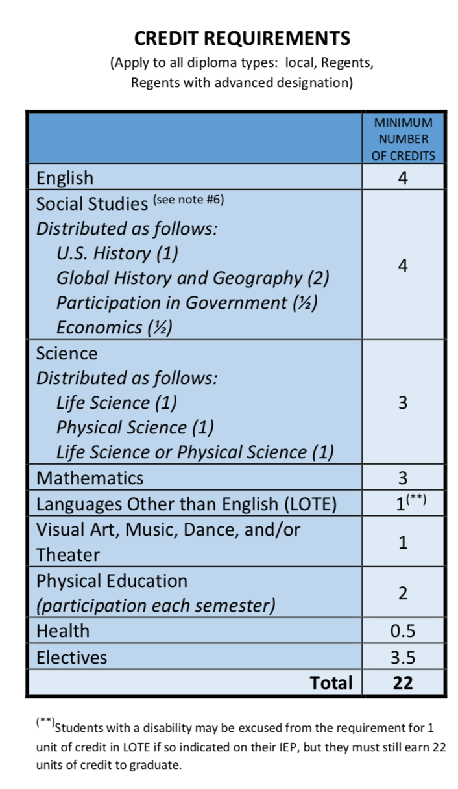

# LHS PSI aligns to the following New York State Science Learning Standards

* Asking Questions and Defining Problems
* Developing and Using Models
* Planning and Carrying Out Investigations
* Analyzing and Interpreting Data
* Engaging in Argument from Evidence
* Obtaining, Evaluating, and Communicating Information
* Using Mathematics and Computational Thinking
* Constructing Explanations and Designing Solutions

# **LHS PSI**

# STUDENT EXPECTATIONS

# High Expectations = Higher Student Performance

# LHS PSI students are expected to:

* Arrive to Class On Time
* Conform to the district-wide Attendance Policy
* Work to the best of your ability when completing all assignments
* Ask questions if you do not understand anything
* Complete all assignments ahead of the deadline date
* Keep your laboratory well-organized and up to date
* Learn how to work outside your comfort zone so you can grow
* Compete with yourself and not with others in the class
* Attend LSH PSI Sponsored Field Trips
* Participate and Successfully Complete a Summer Science Research Internship
* Participate in Regional and National Science Competitions
* Attend the Annual Science Symposium, LHS PSI Lab Coat Ceremony, and Senior Graduation.

# LETTER OF INTENT

# Lincoln High School Program for Scientific Inquiry

NAME____________________________SCHOOL_____________________

ADDRESS___________________________Year of Graduation_______ CITY________________________STATE___________ZIP________________

TELEPHONE( )__________________Date of Birth________________

PARENT OR GUARDIAN___________________________________________

EMERGENCY CONTACT NAME AND PHONE_____________________________

As a member of the Program for Scientific Inquiry, I understand that I am making a commitment to the full four years of the program.

When you join the Program for Scientific Inquiry you are making a commitment to the

following :

1. In order to be placed in a summer internship, I must :Successfully complete and pass all my PSI courses with a 90 average or better, have excellent academic standing in my core science and math courses and achieve an excellent record of attendance and punctuality, submit a resume and participate in at least one mock interview.
2. I must report for LHS PSI activities, job interviews and work dressed appropriately.
3. Once placed in my internship, I am responsible for whatever task I am assigned by my research institution mentor. I will be required to communicate with the PSI Program Director, Dr. Saghafi once a week to discuss how the internship, and data collection process is going.
4. Upon completion of my science research projects, I will be responsible to participate in the Young Science Achievers Competition, the Westchester Regional Junior Science and Humanities Symposium, the Westchester Science and Engineering Fair, and in the senior year, the Regeneron Science and Talent Search. I will participate in any other science fairs deemed necessary by Dr. Saghafi.
5. I understand that if I do not meet and maintain the requirements of the Program for Scientific Inquiry, I will be asked to withdraw from the program.

In conclusion, I understand that I will receive the "Certificate of Scientific Research" from the Program for Scientific Inquiry, only if I have passed all courses and successfully completed all other requirements as specified above.

I understand that in being accepted into this program I am committing myself to work during the summer of my sophomore and junior year. My acceptance further commits me to be an LHS PSI participant during my entire senior year of high school.

Student's Signature_______________________________________________

Parent 's Signature_______________________________________________

Director LHS PSI____________________________________________________

|  |  |  |
| --- | --- | --- |
|  |  |  |
|  |  |  |
|  |  |  |
|  |  |  |
|  |  | |

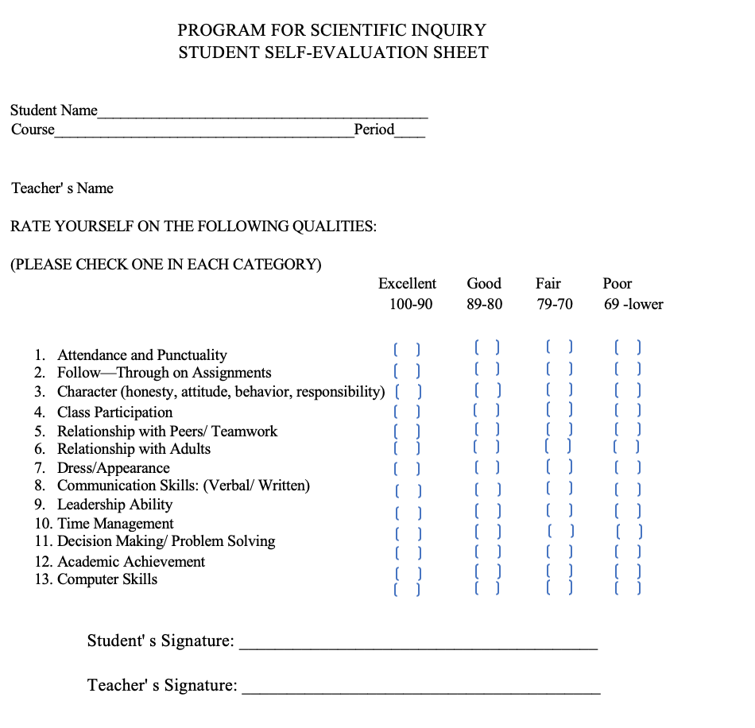

**Careers Opportunities in STEM**

Computer and Information Systems Managers

Architectural and Engineering Managers

Natural Sciences Managers

Computer and Information Research Scientists

Computer Systems Analysts

Information Security Analysts

Computer Programmers

Software Developers, Applications

Software Developers, Systems Software

Web Developers

Database Administrators

Network and Computer Systems Administrators

Computer Network Architects

Computer User Support Specialists

Computer Network Support Specialists

Computer Occupations, All Other

Actuaries

Mathematicians

Operations Research Analysts

Statisticians

Mathematical Technicians

Mathematical Science Occupations, All Other

Architects, Except Landscape and Naval

Landscape Architects

Cartographers and Photogrammetrists

Surveyors

Aerospace Engineers

Agricultural Engineers

Biomedical Engineers

Chemical Engineers

Civil Engineers

Computer Hardware Engineers

Electrical Engineers

Electronics Engineers, Except Computer

Environmental Engineers

Health and Safety Engineers, Except Mining Safety Engineers and Inspectors

Industrial Engineers

Marine Engineers and Naval Architects

Materials Engineers

Mechanical Engineers

Mining and Geological Engineers, Including Mining Safety Engineers

Nuclear Engineers

Petroleum Engineers

Engineers, All Other

Architectural and Civil Drafters

Electrical and Electronics Drafters

Mechanical Drafters

Drafters, All Other

Aerospace Engineering and Operations Technicians

Civil Engineering Technicians

Electrical and Electronics Engineering Technicians

Electro-Mechanical Technicians

Environmental Engineering Technicians

Industrial Engineering Technicians

Mechanical Engineering Technicians

Engineering Technicians, Except Drafters, All Other

Surveying and Mapping Technicians

Animal Scientists

Food Scientists and Technologists

Soil and Plant Scientists

Biochemists and Biophysicists

Microbiologists

Zoologists and Wildlife Biologists

Biological Scientists, All Other

Conservation Scientists

Foresters

Epidemiologists

Medical Scientists, Except Epidemiologists

Life Scientists, All Other

Astronomers

Physicists

Atmospheric and Space Scientists

Chemists

Materials Scientists

Environmental Scientists and Specialists, Including Health

Geoscientists, Except Hydrologists and Geographers

Hydrologists

Physical Scientists, All Other

Agricultural and Food Science Technicians

Biological Technicians

Chemical Technicians

Geological and Petroleum Technicians

Nuclear Technicians

Environmental Science and Protection Technicians, Including Health

Forensic Science Technicians

Forest and Conservation Technicians

Life, Physical, and Social Science Technicians, All Other

Computer Science Teachers, Postsecondary

Mathematical Science Teachers, Postsecondary

Architecture Teachers, Postsecondary

Engineering Teachers, Postsecondary

Agricultural Sciences Teachers, Postsecondary

Biological Science Teachers, Postsecondary

Forestry and Conservation Science Teachers, Postsecondary

Atmospheric, Earth, Marine, and Space Sciences Teachers, Postsecondary

Chemistry Teachers, Postsecondary

Environmental Science Teachers, Postsecondary

Physics Teachers, Postsecondary

Sales Representatives, Wholesale and Manufacturing, Technical and Scientific Products

Sales Engineers

# PARENTS

# your children need your help!

# Here's How You Can Assist Your Children:

* Demonstrate an interest in your children's education. Each day, ask your children, "What did you learn in school today?"
* Make sure that your children attend school regularly and on time.
* Schedule a time and place for homework. Ask to see completed assignments.
* Praise your children for their success in academics.
* Seek tutoring service when necessary.
* Make sure that your children have enough sleep and eat properly.

# Internship Partners

* Regeneron Summer Research Program
* University of Maine SMART Program
* Rockefeller University Science Outreach Program
* MIRTHE Program
* Memorial Sloan Kettering HOPP Summer Student Program
* Lehman College
* City College
* Albert Einstein College of Medicine
* Yeshiva University
* Hunter College
* New York Medical College's STAR Program
* Iona College
* Rochester Medical Center
* Girls Who Code
* Sophie Davis School of Biomedical Education
* Columbia Medical College’s S-Prep Program
* Sarah Lawrence High School Summer Research Program
* Manhattan College High School Summer Engineering Program
* CURB at Beczak (Sarah Lawrence College)
* Bronx Zoo Summer Research Experience (Fordham University)
* University of Massachusetts Lowell

# Competitions

* + Regeneron Science Talent Search **November**
  + Westchester Regional Junior Science and Humanities Symposium **February**
  + Westchester Engineering and Science Fair **March**
  + Westchester Tri-County Science Fair **April**
  + Google world science fair
  + ACT-SO
  + Young Science Achievers Program/Competition, Grant Proposal deadline in **Decembe**r and Final Paper due in **May;** Science Symposium held at AT&T Global Network Headquarters, Bedminster, NJ **June**

# Program for Scientific Inquiry Advisory Board